**Financial Management and Risk assessment of Lending Club**

**Introduction:**

Lending club is an online platform that helps borrowers find personal loans, financing, and business loans. The club joins investors with the lenders which allows investors to get great returns. One of the major goals of the company is to improve the loan default rates. The management’s strategy to make this improve is the following:

1. Identify the risk of loans quantitatively (in numbers) from the credit history of lenders. This will help to determine whether or not to approve the loan request.
2. Estimate how much principal will be returned from a particular lender after completion of loan term.
3. Identify the management strategies that improve the loan default rates.

In this report, we use exploratory data analysis and machine learning techniques to address these problems.

**Lending Club’s Performance:**

Lending club began its service in 2007. The club gained popularity quickly after it showed up in the market. In the year of 2007, the club funded only a couple of hundred thousand dollars to the lenders. This has become in the order of several millions in 2016. These numbers are show a rapid growth of the company’s business.

In average, only 85% of the lenders pay the loans in time. The remaining customers make late payments or are charged off. The charged off loans goes through the loan collections and some of that is recovered with a collection fee. The major goal of the company is to improve the fraction of late/charged off payments. But Over the years, this number has not improved.

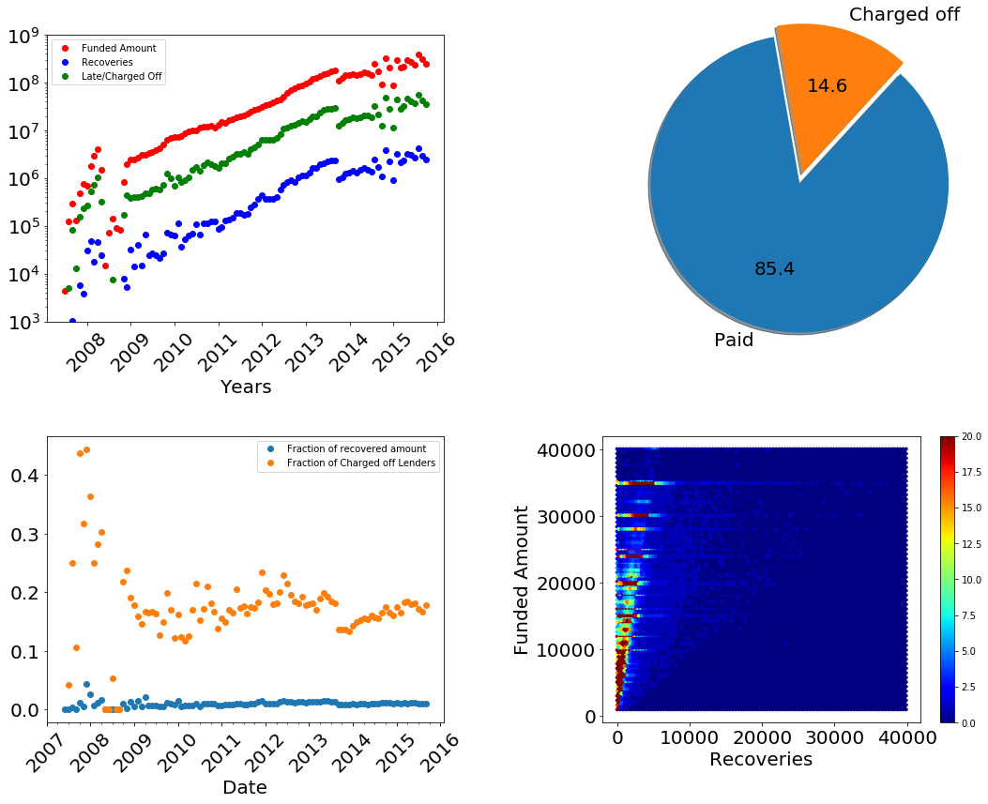

Figure 1: (upper left). Performance of the company over the past years. (upper right) Proportion of paid and late/charged off loans. (lower left) Fraction of charged off lenders and amount recovered from them. (lower right) Density of funded amount and recoveries.

**Predicting next year’s business:**

The amount invested to the lenders increased very rapidly until mid-2015. After then, the growth slows down. The growth can be mathematically modelled by a logarithmic function. This model predicts that the company will require three hundred million dollars of investment in the next year. 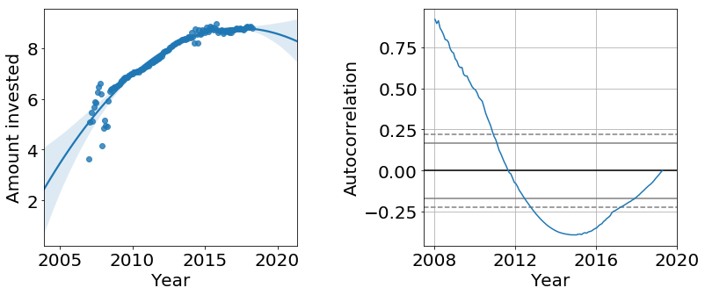

Figure 2: Logarithmic values of amount invested over time. The solid line is a model that predicts the amount. Shaded line represents the 95% confidence intervals.

**Understanding the lenders:**

Most of the lenders have annual income less than a hundred thousand dollars. Majority of lenders have total current credit balance below five times their current annual income. The main reason to borrow the loan is to consolidate their debt and pay their credit card loans. This indicates that most of the customers are already facing financial problems.

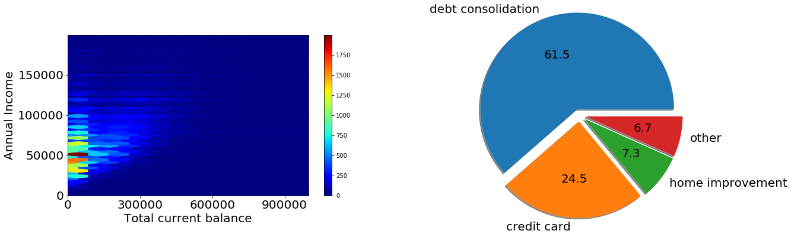

Figure 3: (left) Density of lenders by annual income and total current balance. (right) Proportion of lenders with the purpose of loan.

**Distribution of Lenders:**

Loan above $25,000 are mostly given to the income verified lenders. There is seemingly no big difference between the loan distribution between paid and charged-off lenders.

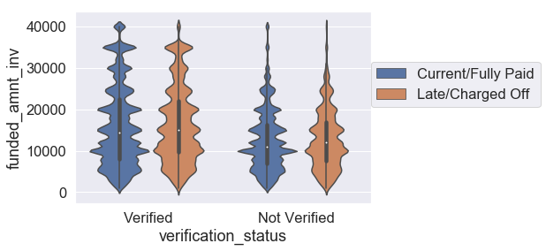

Figure 4: Kernel density plot of loans for verified and unverified lenders.

**Important features:**

Understanding how the credit history of lenders is related to the loan status (paid or charged off) is one of the important questions for the management. We did a quick survey on the relation between loan status and remaining features. It shows that “*account opened in past two years”* is the most important feature among others. Important features affecting the loan status are below.

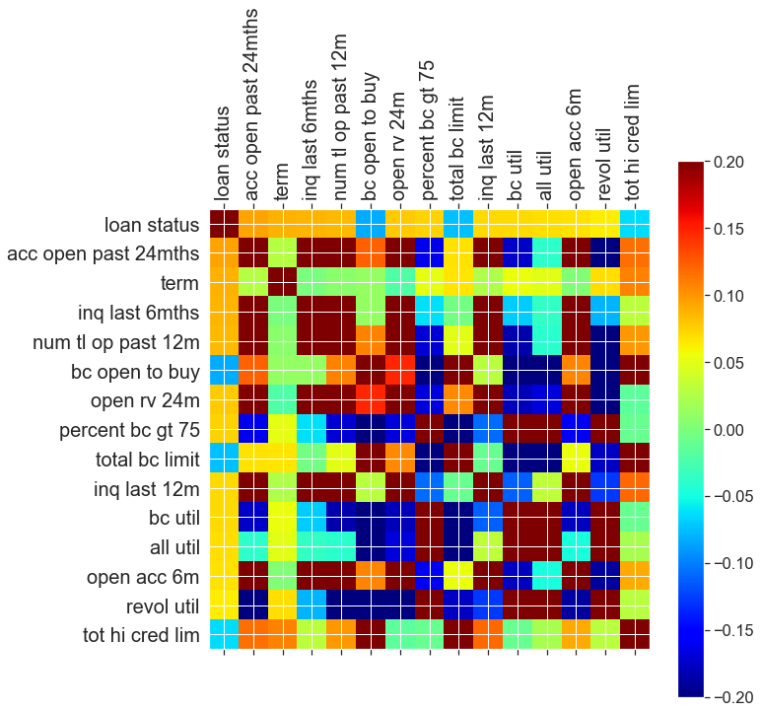

Figure 5: Important categories that impact loan status.

**Role of recent history:**

The credit history of lenders tells a lot about the loan status. Lender with better credit conditions are more likely to pay the loans. For example, lenders with high open to buy ratio (The ratio of maximum credit limit to the current balance on the account) have significantly smaller risk. The lender with more accounts open in past years or inquiries are less likely to pay the loans in time. The error bars represent 99.99% confidence interval.

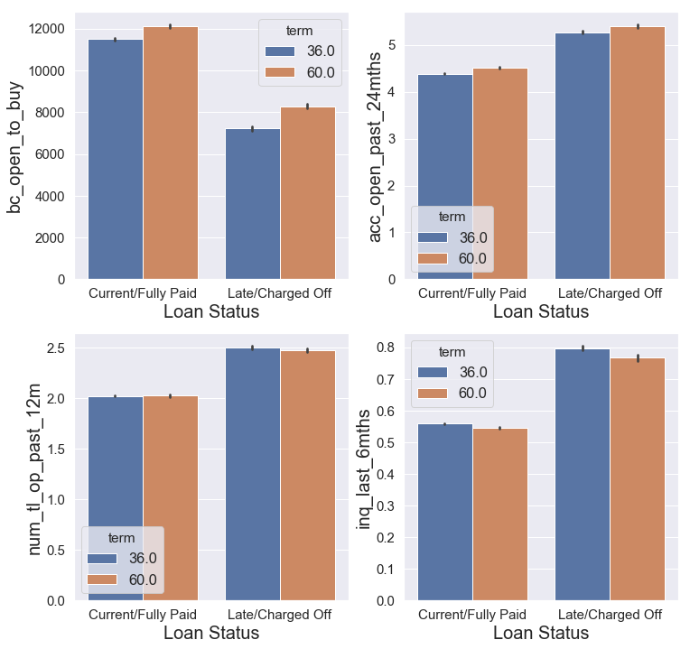

Figure 6: Risk of loans for different categories.

**Role of long-term credit history:**

The long-term credit history impacts the risk of loans but not as much as the recent credit history. Below are the histograms or Kernel density Estimation plots of some of the features. Lenders having shorter credit history have only slightly more risk compared to those who have long credit history. The annual income does not make much different on the risk factor. This is because the real income can be different since not all Lenders are show verified income. But the DTI (A ratio of the lenders total monthly debt to the total debt obligations), which reflects the current financial condition of lenders makes more contribution to the risk factor. Lenders with lower DTI are more likely to pay the loans in time.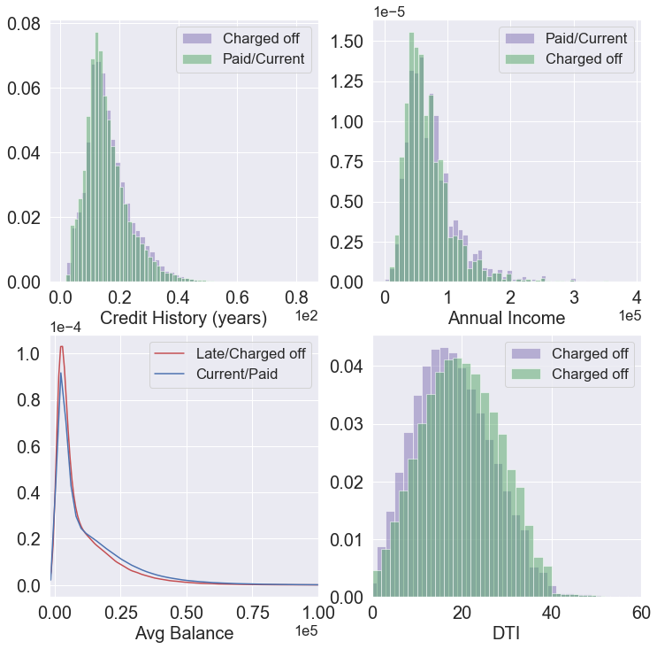

Figure 7: Risk of loans for different categories.

**Role of loan terms:**

Independent of whether the loan term is three or five years, the risk of default loan increases sharply until a year and falls down over time. 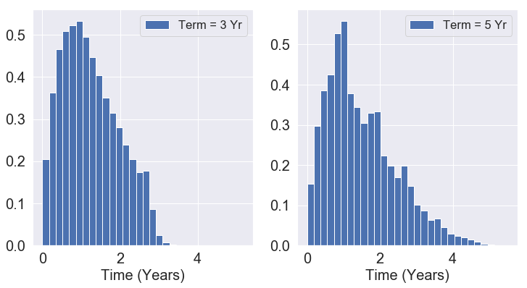

Figure 8: Histogram showing risk of late/charged off loans.

**Quantifying the risk:**

The five-year loan term has double the risk compared to the three-year loans. However, the risk does not change much with the loan amount.

The risk also depends on the purpose of the loans. Loans for small business and education have much higher risk compared to other categories.

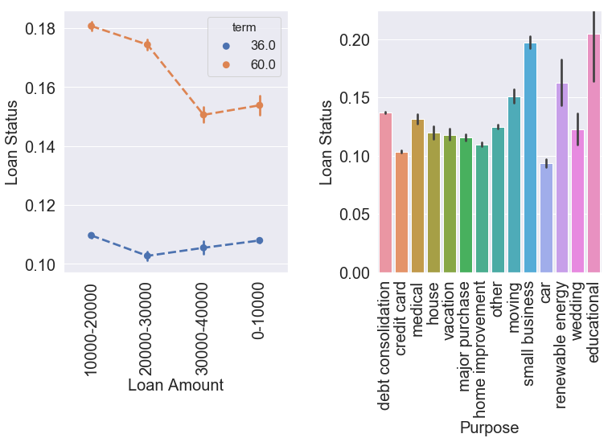

Figure 9: (left) Loan status for five- and three-year terms. (right) Risk of loans for various purposes.

**Predicting returns:**

One of the company’s goal is to estimate the fraction of the loans that is returned to the company or investors. Using linear regression, I estimated the amount returned to the company/investors. Figure 10 shows the predicted values of the ‘total received principal’ versus the real test values.

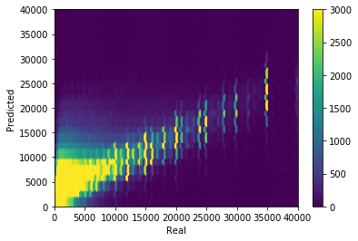

Figure 10: Predicted versus actual values of “total received principal”.

**Risk Assessment:**